Take one last good look at yourself in the mirror...because I’m about to rock your face off. Introducing Deco, the Design Editor for Custom Objects. Deco lets you define your own custom object UI without the need for custom code.
Deco allows you to define your own dialog when creating a new custom object. It allows you to define your own edit dialog. And it allows you to have a custom tab for viewing your custom object data.
Create your user interface using Visual Studio: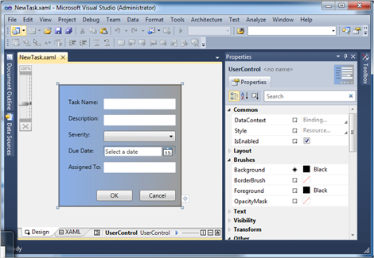
Hook it in to Vault Explorer: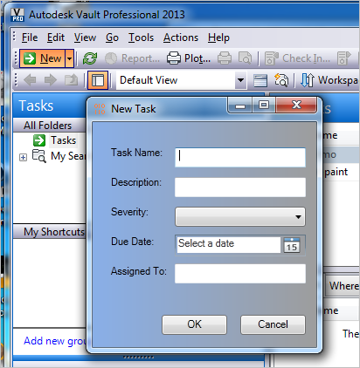
Deco can’t do everything, however. Complex UI will still need custom programming. But Deco should hit most of the common cases. Specifically “property page” type functionality, where you want to display or edit the properties on a single object.
It’s probably best if you watch the how-to video on my Youtube channel.
In other news, I now have a Youtube channel. There is not much up there right now, but I’ll be porting over most of the videos from this blog.
For those of you blocked from Youtube, here is a download link: http://justonesandzeros.typepad.com/Videos/Deco/Deco.wmv

Requirements:
- Vault Professional 2013
- XAML editor such as Visual Studio 2010 or Expression Blend
Click here for the application
Click here for the source code

Current limitations:
- Custom Objects only. No support for files, folders, items, and so on.
- Vault Professional 2013 only, since that’s the only product with custom objects.
- Vault data can only be hooked to TextBox, CheckBox, ComboBox an DatePicker controls.
- The XAML files and Settings.xml need to be distributed to all clients in order for them to see the custom UI. This issue will be addressed in the next release of Project Thunderdome.
As with all the samples on this site, the legal disclaimer applies.

